Chapter 4 Results and discussion

4.1 Introduction

This chapter presents the result of the user interface of the developed application. The features and performance testing of the application will be discussed in this chapter too. In addition, the problems and obstacles faced during the application development will be discussed and reviewed in this chapter.

This ride sharing application will enable user to book EV rides to travel within UPM Serdang campus. Other basic features such as managing and editing the booking, viewing the user and EV’s location are also included.

4.2 Main Screen

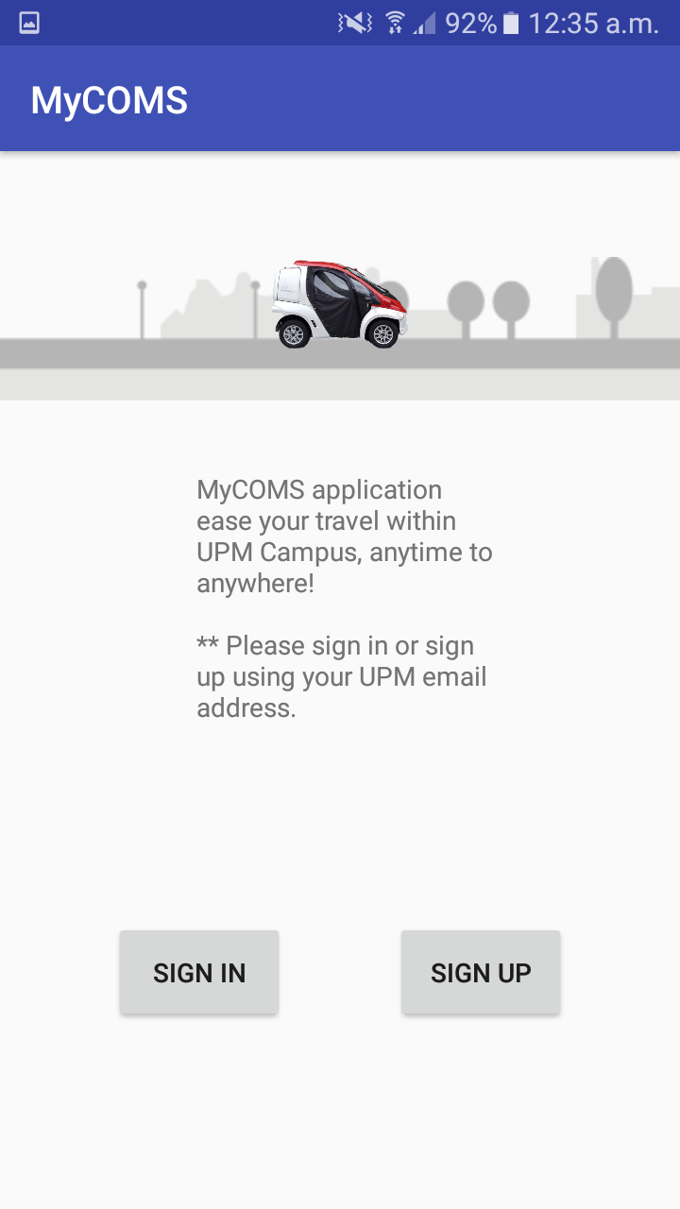

Figure 4.2.1: Main Screen of the application.

Main screen is the first screen shown when user activate or runs the application by clicking onto the app. In the main screen, the name of the app is shown on the action bar, as shown in figure 4.2.1. There are two buttons available for the users such as “Sign In” and “Sign Up”.

4.3 User Authentication

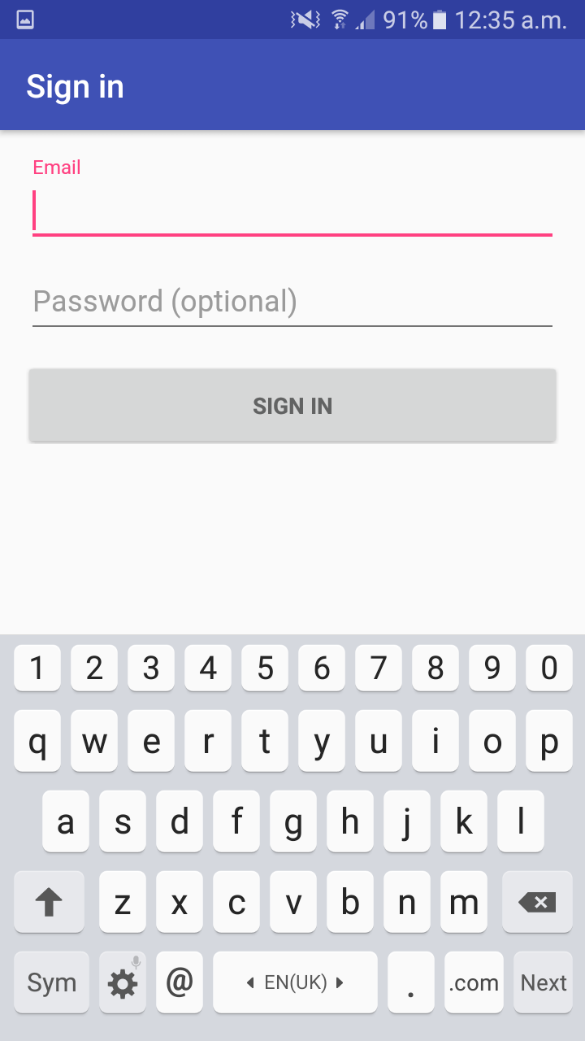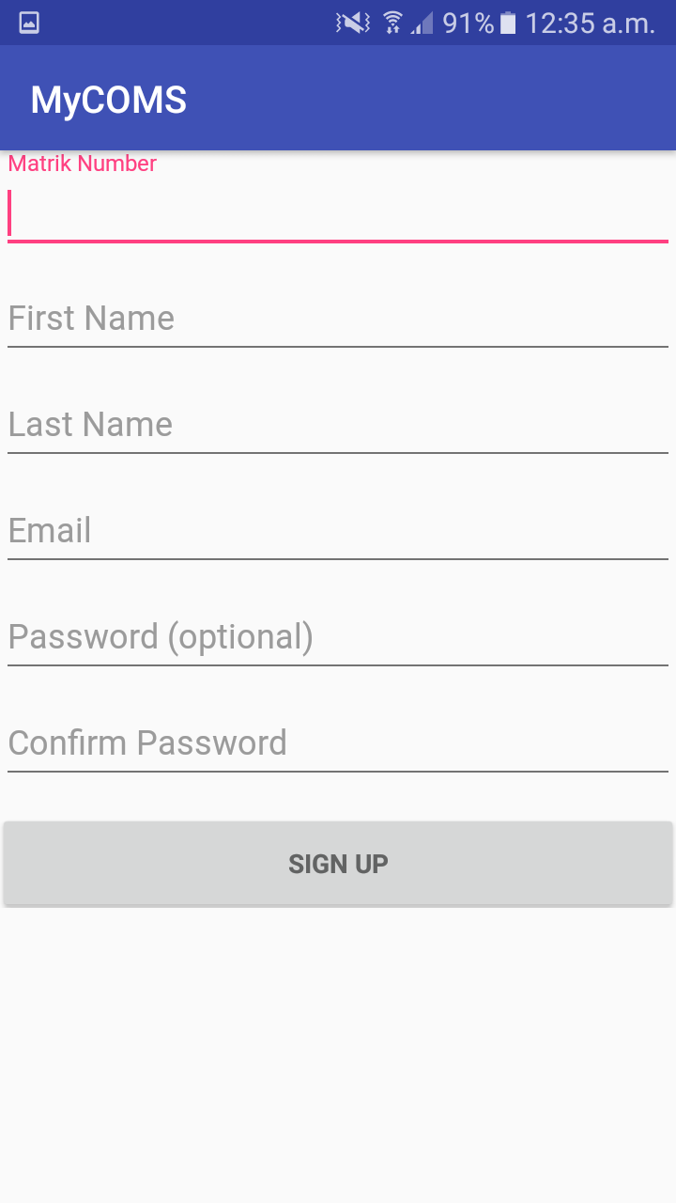

Figure 4.3.2: Sign up screen for user to register.

Figure 4.3.1: Login screen to authenticate user.

As shown in figure 4.3.1 and 4.3.2, sign-in and sign-up screen which is provided for user to authenticate the user, and also creating new account or register to the database as a new user. User will have to enter details such as Matric Number and UPM email address to verify that he/she is student of the university.

4.4 Home Screen

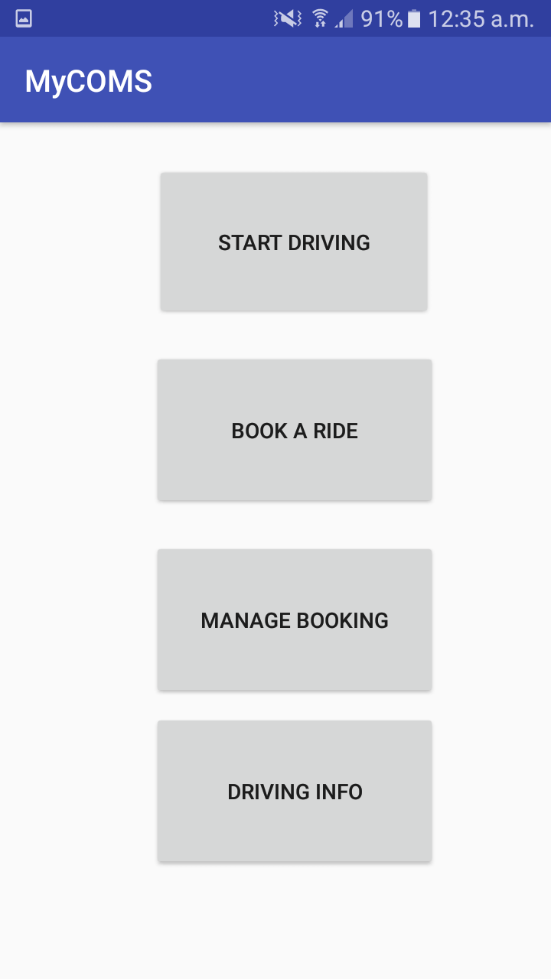

Figure 4.4.1: Home screen of the app.

Once user completed user authentication process by having entering credentials, user will be brought to home screen as shown in figure 4.4.1. The home screen is the main interface after the user verification, as it acts as the central for navigation of functions of the app. There is 4 buttons on the screen such as “Start Driving”, “Book a Ride”, “Manage Booking” and “Driving Info”.

4.4.1 Start Driving

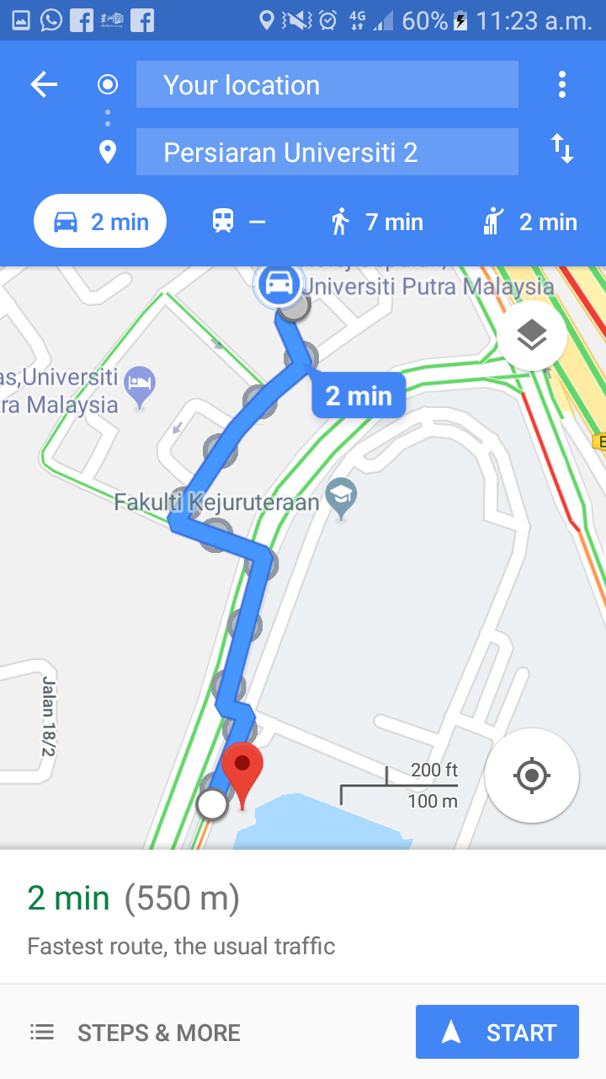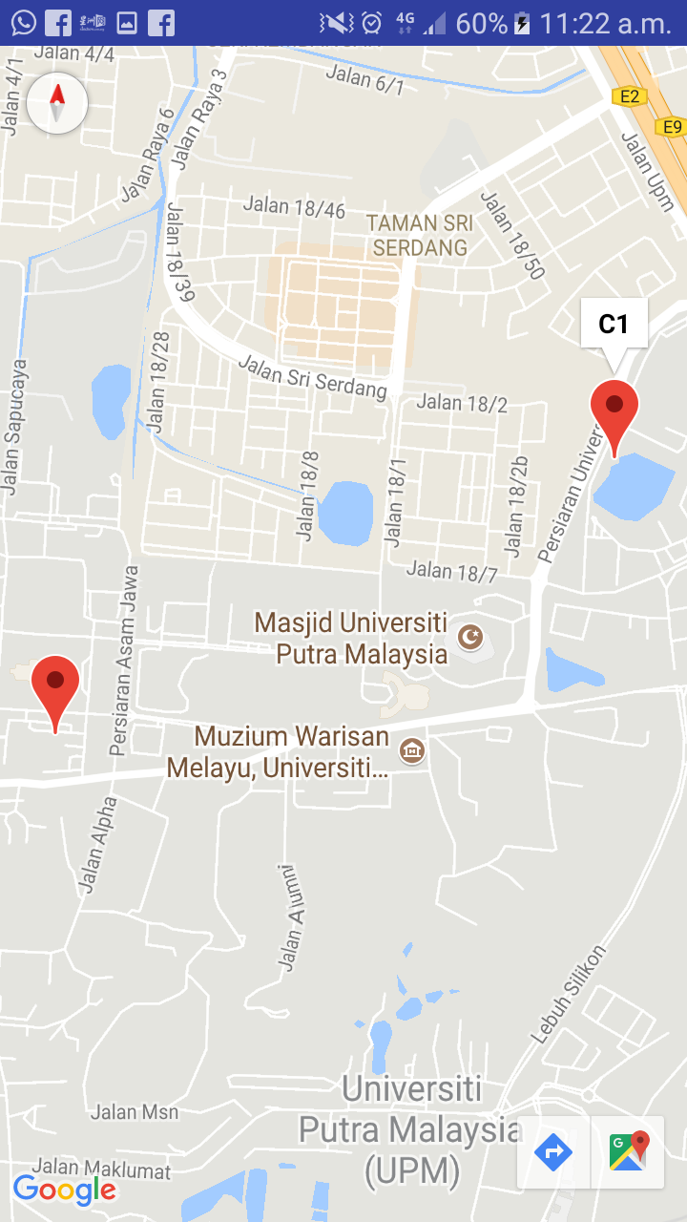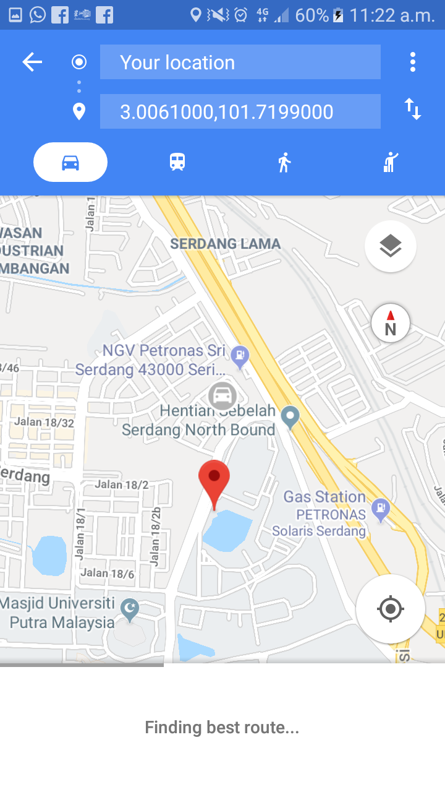

Figure 4.4.1.1: Start Driving screen of the app.

User will be directed to google maps where to show the location of the available EVs. User can press the button on the screen of the maps to navigate to the exact location of the EV by using Google Maps navigation.

4.4.2 Book A Ride

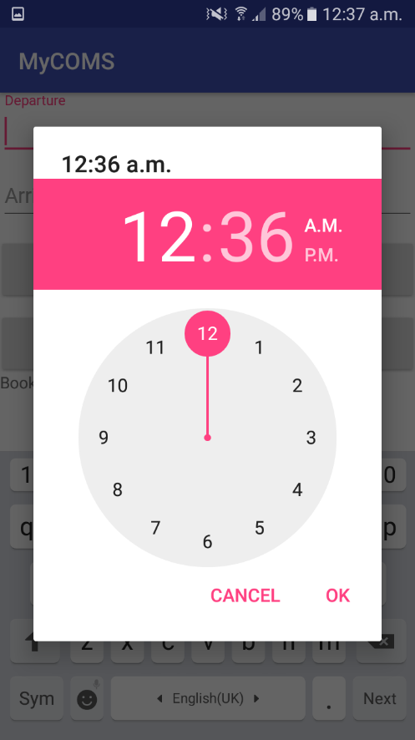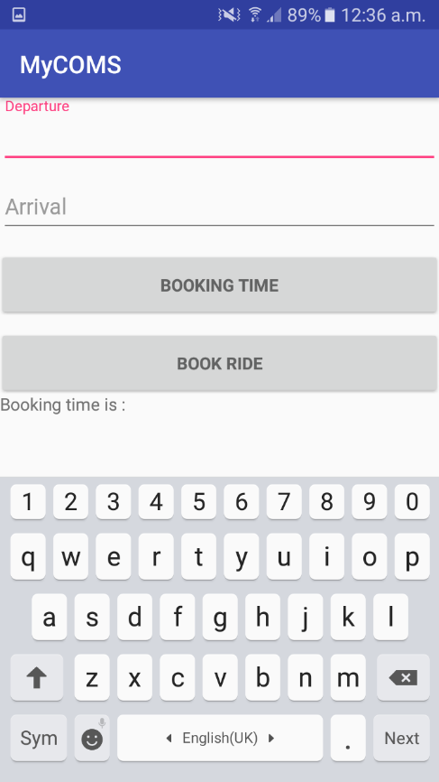

Figure 4.4.3.1:Book a ride screen of the app.

Figure 4.4.3.1 shows the screen for book a ride button. User will be able to book the EV’s slot using this button. User will be prompt to enter departure and arrival location, including the desired booking time. All the data will be recorded in database, and can be view by admin for monitoring purpose.

4.4.3 Manage Booking

4.4.4 Driving Info

Figure 4.4.4.1: Driving info screen of the app.

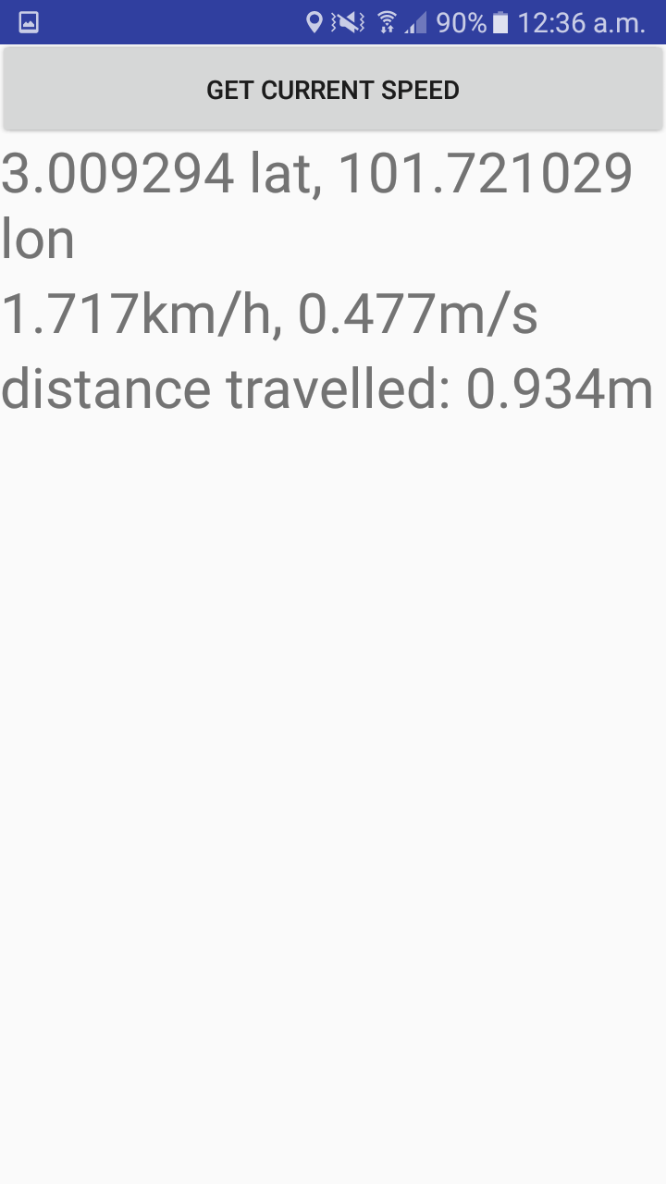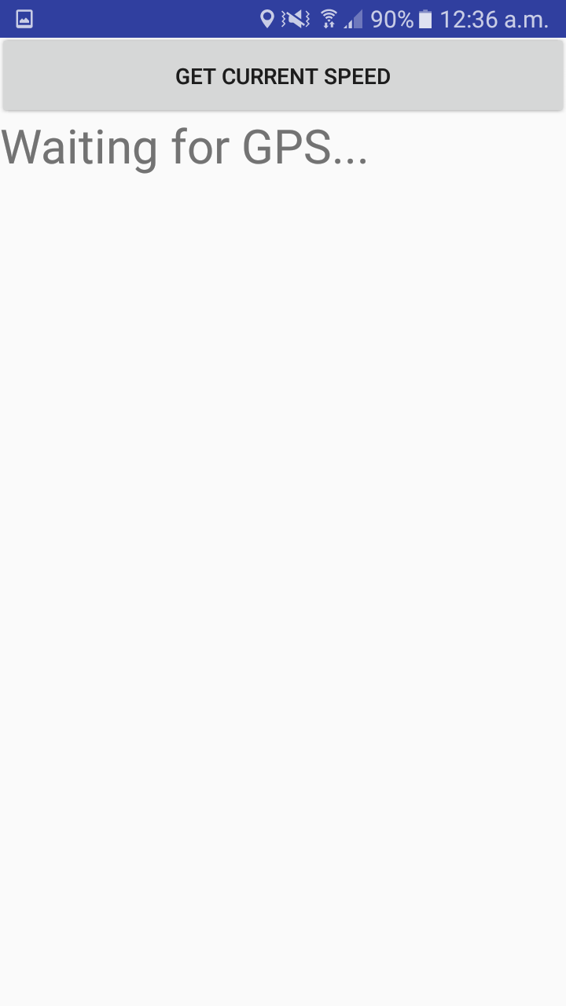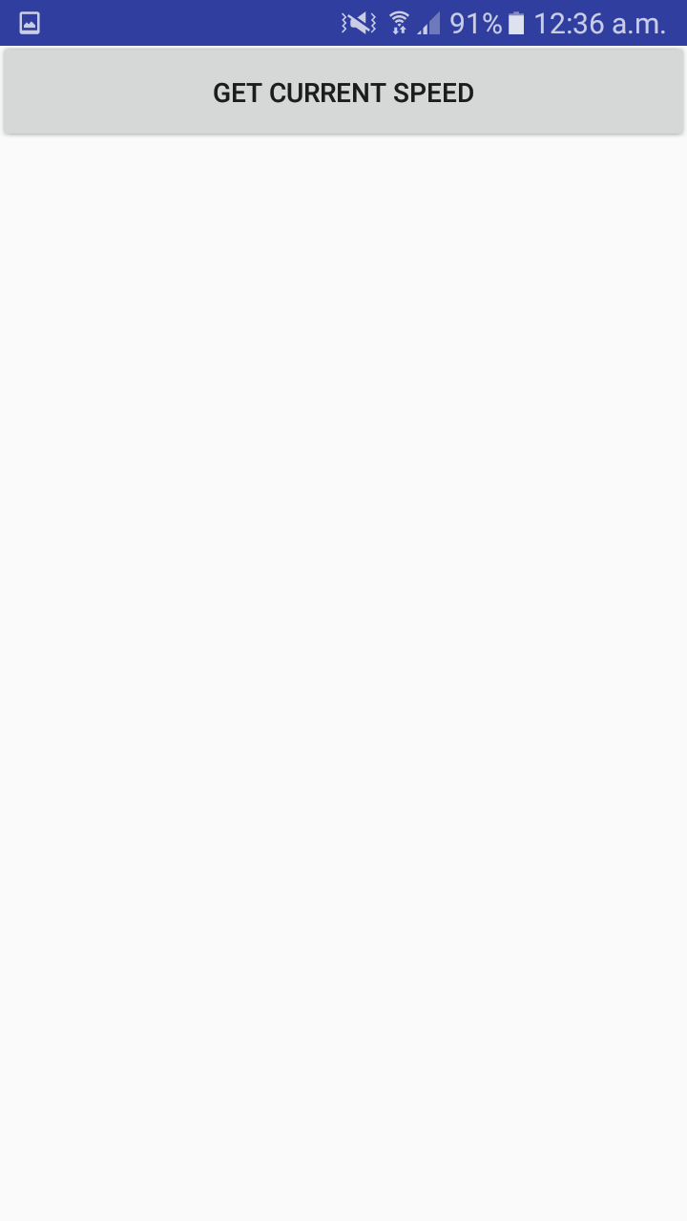

Figure 4.4.4.1 shows the interface of driving info screen. When user does not need navigation by google maps, user can access this button to find out the location in GPS-coordinates, speed and also the mileage travelled when the app is active. User will be prompt to activate the GPS function in the phone to ensure that the data is captured. The data retrieved from this activity will be tabled into database for administrative purpose. Admin can refer to the database to track the whereabouts of the user, to ensure that user does not go out of bounds of UPM Serdang campus. Algorithm is imposed to act as geo-fencing to notify user whenever user is using the app outside the campus area.

4.5 Performance Testing

The MyCOMS app is tested in different type of Android devices, which are Samsung Galaxy J7, Redmi Note 4 and Asus Zenfone 5. All the features in the application are working well. However there is slight difference in the accuracy of the GPS coordinate as different devices has different sensitivity of GPS and different modules are used. User will have to wait for a few moment for the GPS sensor to calibrate the accuracy of the coordinate.

4.6 Summarize

The GPS coordinate and speed obtained from the driving info component is the latitude and longitude of the user, and estimated speed of the user based on the calculation from built-in GPS module. The location coordinate is updated constantly in database repeatedly to maintain latest information of the user and EV. The location is tracked real-time and is displayed on the map.

4.7 Limitation

This EV booking app is restricted to Android based smart phone only. This application will work when there is connection to the internet. The navigation, user info collection and also booking managing and selection requires internet access to send the data to the database. User will need internet connection to retrieve the constant update of the location of the EV before creating booking request. The location of the user can only be estimated due to the sensitivity of the GPS module from the Android mobile phone.